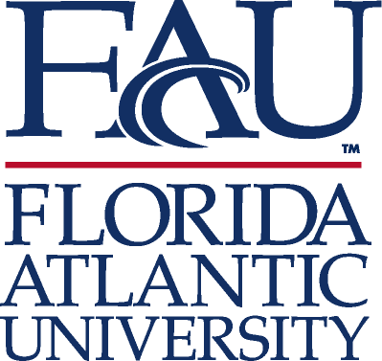

Division of Student Affairs

Associate Vice President and Dean of Students Office

ANNUAL REPORT

2009-2010

I. MISSION STATEMENT
The Associate Vice President and Dean of Student Affairs Office exists to assist students in meeting their educational goals by offering assistance with academic matters and leadership and student development opportunities, through individual advising.

- VISION
The Associate Vice President and Dean of Students Office will provide exemplary programs and services to the university community through promotion of leadership, accountability, responsibility while building lifelong relationships.

- CORE VALUES
- That each student is treated with respect and individualized attention.
- That a student will receive the proper assistance and or a referral when an extenuating circumstance prevents a student from succeeding academically.
- That leadership, growth and student development opportunities are fostered through an active Greek community, founded on the principles of scholarship, leadership, service, and lifelong relationships.
- That students are accountability and personal responsibility be upheld through the Student Code of Conduct.
- That through advising and sound financial decisions student government leaders will uphold their mission to offer services and programs for the betterment of the student body.

IV. ORGANIZATIONAL CHART AND STAFF LISTING

Dr. Corey A. King, Associate Vice President and Dean of Students
Terry Mena, Associate Dean of Students
Joanna Ellwood, Assistant Dean of Students (*started on February. 1, 2010)
Luci Neborski, Office Manager
Barbara Szostek, Executive Secretary
Jem Volny, Program Manager
Peggy Joseph, Communication Officer
Tori Spokane, Graduate Assistant

Organizational Chart (SEE APPENDIX A)
V. ACCOMPLISHMENTS

- Fully implemented a multidisciplinary Student Crisis Awareness Committee/Student Intervention Team (SCAC/SIT) to address intervention and management of troubled and difficult students and respond in an emergency to students who pose a threat to self or others.

- Hosted a campus-wide Student Veterans Seminar to bring awareness of student veteran issues and services at FAU and the community

- Implemented a multidisciplinary Non-Traditional Student Advisory Team to address the scope and needs for Non-Traditional Student resources at FAU.

- Implemented a working team to address the growing needs of the Graduate students in partnership with Graduate Studies, in particular, towards Graduate Orientation and Graduate Student Association Research Day

- Guided the hiring of a new Associate Dean of Students, Broward Campuses, through a national search.

- Implemented an action plan based on the recommendations from the University Inspector General Audit Report for Student Government to address the SG Audit findings.

- Implemented a centralized management and database program for Student Conduct process and cases (TJO).

- Developed Alcohol and the Law, Ethical Decision Making and Anger Management workshops/seminars as educational sanctions within the Student Code of Conduct.

- Continued to facilitate the coordination of a comprehensive late night programming calendar.

- Advised and guided a University-wide committee that reviewed and submitted changes to Regulations 4.006 and 4.007 to the Sr. Vice President of Student Affairs.

- Reorganized the divisional committee selection process to attract a broader array of participation within the division.

- Created and implemented a new Learning Community with a commuter focus and emphasis.

- Established and implemented a comprehensive student code of conduct training program for student conduct managers and student conduct board members.

- Collaborated with the New Student Orientation Office in expanding the orientation schedule to incorporate more traditional events and parental involvement.

- Collaborated with Today and Beyond Wellness, Student Health Services and Counseling Center in obtaining a new on-line Alcohol education program through Alcohol EDU program.

- Established Breezeway Ambassadors Program.

- Provided divisional representation on the University Policy Committee in addressing the new and updated policies related to Drug Free-Environment, Designed Public Forum, Distribution of Printed Materials, Identify Theft Prevention Program, Fraud, Consensual Relations, University Gift Solicitation and Acceptance, Golf Cart Usage, Breezeway Safety (Bicycles, Skateboards, Skates and Scooters), Student Employment, and Personnel.

- Assisted maintaining and updating the divisional strategic plan by providing leadership to the Strategic Planning Team charged by the Sr. Vice President for Student Affairs.

- Continued to serve and provide leadership to the Student Union staff and operations during the directorship vacancy.

- Continued to streamline the Division of Student Affairs and departmental websites and communication through a working group of the technology/communication representatives within the Division.

- Re-established a vendor to print a quality student handbook that will be self-sustaining and generate additional revenue.

VI. 2009-2010 GOALS

- Partner with Undergraduate Admissions and Graduate College in streamlining graduate and international student services and experience. ONGOING
- Established a fully functional department of Student Code of Conduct. ACCOMPLISHED
- Collaborate with Student Involvement and Leadership to establish advisory boards that will create streamline process for campus life and programming. ACCOMPLISHED
- Establish a Student Media board at the University. ONGOING
- Continue the traditional functions (Chief Judicial Officer and Divisional Ombudsman) of the Dean of Students Office. ONGOING
- Enhance the departmental programs and services under the scope of the Associate Vice President and Dean of Student that will address University Strategic Plan for enhancing the amenities, programs and services at the University. ONGOING
- Charged a University-wide committee to review and submit any changes to Regulations 4.006 Student Government and Student Organizations and Regulation 4.007 Student Code of Conduct to Sr. Vice President of Student Affairs. ACCOMPLISHED
- Addressed the recent SG Audit outcomes by establishing SG Accounting and Budget website, manual and in person and on-line, through Blackboard training program that will incorporate the state of Florida statutes, Florida Atlantic University regulations and policies for appropriate use of Activities and Service Fees. ACCOMPLISHED
- Clarify the scope and function of Standing Committees and Working Teams within the Division of Student Affairs. ACCOMPLISHED
- Continue to support the growth of the Leadership Committee mission and function within the University. ONGOING
- Examined the current and potential new Learning Communities at the University. ACCOMPLISHED
- Hired a new Assistant Dean of Students through a national search. ACCOMPLISHED
- Establish a Student Code of Conduct Training program for Student Conduct managers and for Student Conduct members and Hearing Officers. ACCOMPLISHED
- Continue to develop the Student Crisis Intervention Committee process, internal assessment model for student cases, and communication and training programs/presentation to faculty, staff and students on how to identify and help distressed/disruptive students. ACCOMPLISHED
- Re-write or establish forms for the amended and new Regulations 4.007, 4.013, 4.014 and Student Crisis Intervention Committee. ACCOMPLISHED
- Work with Student Orientation to re-design schedule to incorporate the Student Code of Conduct Office and an expanded presentation on Campus Safety, along with University Police and Student Crisis Intervention Committee. ACCOMPLISHED
- Help administer the new alcohol and other drug program within the Student Code of Conduct sanctions and guide the program development to eventually become a mandatory program for all entering and transfer students at the University. ACCOMPLISHED
- Continue to represent the Division on the University Policy Committee and addressing the new or updated policies in the following areas: Student Employment, Free Speech Area, and Drug Free Campus. ACCOMPLISHED
- Hire a new Director of Student Media through a national search. ACCOMPLISHED
- Establish a training model and program for students within the Student Media and create the new Media Advisory Board. ONGOING
- Examine other funding sources to provide a hand copy version of the Student Handbook. ACCOMPLISHED
- Fundraise or seek donations towards program and services within the Division of Student Affairs. ONGOING
- Advise International Student Services and Scholars with establishment of their advisory board. ACCOMPLISHED
- Continue to development and implement, as it related to meeting the University and Divisional Strategic Plan, the Council for the Advancement of Standards (CAS) in Higher Education, and assessment for the functional areas within the Division of Student Affairs. ONGOING
- Implement the multidisciplinary Student Crisis Awareness Committee/Student Intervention Team (SCAC/SIT) to address intervention and management of troubled and difficult students and respond in an emergency to students who pose a threat to self or others. ACCOMPLISHED
- Determine the scope and needs for Veterans resources at FAU. ACCOMPLISHED
- Support the growth and development of Graduate Student Association. ONGOING
- Hire a new Director of Student Media and Director of Student Government through a local and/or national search. ACCOMPLISHED
- Hired a new Associate Dean of Students, Broward Campuses, through a national search. ACCOMPLISHED
- Hire a new Assistant Dean of Students through a national search. ACCOMPLISHED
- Implement the recommendations from the University Inspector General Audit Report for Student Government. ACCOMPLISHED
- Implement a centralized management and database program for Student Conduct cases.
- Establish a Student Media board at the University. ONGOING
- Develop Ethical Decision Making and Anger Management workshops/seminars as educational sanctions within the Student Code of Conduct. ACCOMPLISHED

VII. ADVANCEMENT OF THE FAU STATEGIC PLAN

With the university aspiring to become a more traditional campus, the Associate Vice President and Dean of Students Office supported the advancement of the FAU Strategic Plan through several projects and initiatives. First and foremost, we continued to support and grow our current initiatives in their second year (i.e., “Late Night FAU” program, Student Leadership initiative, and Student Crisis Awareness Committee and Student Intervention Team) which enhanced and supported the FAU student’s experience. Furthermore, we launched several new initiatives, including the Student Veterans Advisory Team. The team consists of divisional and university resources specific to the needs of student veterans. The advisory team works collaboratively to provide a comprehensive approach to student Veterans services at Florida Atlantic University. Additionally, we increased the number of Fraternity and Sorority student organizations at FAU. These student organizations foster institutional commitment to student satisfaction and academic success. They are also known to promote and improve the retention rates of our students. Lastly, we launched “Camp Owls” program which consists of two-part program. First part welcomes students to Florida Atlantic University and explores the unique region of South Florida. The trip gives students a chance to make new friends, think about college, and prepare to succeed at FAU. The second part of the program called “Leadership Experience” is designed to awaken the leadership potential within first-year students. Students participate in an off-campus retreat intended to cultivate leadership skills and creativity. We strongly believe these initiatives will provide a more traditional campus experience for FAU students.

VIII. RELEVANT DATA (See Appendices)

IX. 2010-2011 GOALS

- Explore the use of social networks to makert and educate students about our services and programs.
- Improve the student conduct website – updates with data on Hazing information; Deans Certifications and Student Verification; FAQ’s; Victim’s Rights and Witness Info, statistics of conduct cases, and add Disruptive Students panel discussion link
- Create "Dealing with Disruptive Students" presentation for use with academic Associate Dean panel, will be videotaped, and displayed on Dean of Students and other related websites within the Division of Student Affairs.
- Create workshops for campus community on Ethics and community responsibility, Conflict Resolution
- Be a resources to student conduct information at Graduate Student/Teaching Assistant workshops in collaboration with the Graduate College
- Revise training for Student Conduct Board and Hearing Officers (session for new and Session for returners; session for feedback from current hearing officers (include RC’s) – provide these sessions on a regular basis.
- Create/revise internal Office of Student Conduct manual
- Create an assessment plan to measure learning outcomes for students who go through the Student Code of Conduct process
- Prepare for external evaluation and assessment by Southern Association of Colleges and Schools (SACS).
- Develop a Graduate Assistant program model in participation with the College of Education Higher Education Leadership program.
- Collaborate with Fraternity and Sorority Life, Today and Beyond Wellness, FAU Police Dept., Counseling and Psychological Services, and all other Division of Student Affairs team members to enhance the programs and services to the students.
- Create Vision/Strategic Plan for the Office of Student Conduct that is incorporate to the Divisional and University Strategic Plan.
- Clarified and defined the scope and function of Standing Committees, Working Teams, and Advisory Boards within the Division of Student Affairs.
- Review and revise University Regulations in the Chapter 4: Student Affairs.
- Hire a new director of Multicultural Affairs through national search.
- Hired a new director of Student Union through local and/or national search.
- Collaborate with University-wide departments, faculty and student to establish Cultural Theme Month Planning Committees.
- Collaborate with Student Engagement functions to establish a leadership banquet
- Implement a multidisciplinary training program for faculty and staff on how to address and manage students at risk, in crisis or who are disruptive.

X. BUDGET SUMMARY

The Associate Vice President and Dean of Students Office is supported by E&G funding totaling $523,457. This includes staff positions ($475,657), student positions ($36,000), and expenses ($11,800) to support the mission and vision of the office.

XI. CONTRIBUTIONS TO THE UNIVERSITY/DIVISION

Provide membership on the following committees/teams/advisory boards

Divisional
Assessment Committee
Homecoming Committee
Regulation Advisory Team
Strategic Planning Team
Student Crisis Awareness Committee
Student Intervention Team
Student Leadership Initiatives Team
Weeks of Welcome Committee
Student Conduct Working Group
Greek Life Strategic Planning Committee
Exceptional Circumstance/Medical Withdrawal Committee
Greek Life Housing Task Force
Regulation Review Team
Student Eligibility Appeal Board
Student Union Advisory Board
Wellness Task Force
Associate Dean of Students Search Committee

University Wide
Admission Review Board
Financial Aid Appeals Board (Athletics)
University Policy and Procedures Committee
OIP Safety and Security Committee
Student Health Fee Committee
Activity and Service Fee Committee
Facilities Use Committee
Transfer Appeals Board (Athletics)
Enrollment Management Committee
President’s Inauguration Committee
Student Veterans Advisory Team
HR Director Search Committee
University Enrollment Management Conference
Orientation Advisory Committee
Sr. Vice President for Financial Affairs Search Committee
Presidential Inauguration Working Team

EXECUTIVE SUMMARY

OVERVIEW

The Associate Vice President and Dean of Student Affairs Office exists to assist students in meeting their educational goals by offering assistance with academic matters and leadership and student development opportunities, through individual advising. The Associate Vice President and Dean of Students Office will provide exemplary programs and services to the university community through promotion of leadership, accountability, responsibility while building lifelong relationships.

MAJOR ACCOMPLISHMENTS

- Fully implemented a multidisciplinary Student Crisis Awareness Committee/Student Intervention Team (SCAC/SIT) to address intervention and management of troubled and difficult students and respond in an emergency to students who pose a threat to self or others.
- Hosted a campus-wide Student Veterans Seminar to bring awareness of student veteran issues and services at FAU and the community
- Implemented a multidisciplinary Non-Traditional Student Advisory Team to address the scope and needs for Non-Traditional Student resources at FAU.
- Implemented a working team to address the growing needs of the Graduate students in partnership with Graduate Studies, in particular, towards Graduate Orientation and Graduate Student Association Research Day
- Hired a new Director of Student Media and Director of Student Government through a local and/or national search.
- Hired a new Assistant Dean of Students through a national search.
- Guided the hiring of a new Associate Dean of Students, Broward Campuses, through a national search.
- Implemented an action plan based on the recommendations from the University Inspector General Audit Report for Student Government to address the SG Audit findings.
- Implemented a centralized management and database program for Student Conduct process and cases.
- Developed Alcohol and the Law, Ethical Decision Making and Anger Management workshops/seminars as educational sanctions within the Student Code of Conduct.
- Facilitated the coordination of a comprehensive late night programming calendar.
- Created and implemented a “random acts of kindness” program to recognize students for random acts of kindness to the university community and beyond.
- Advised and guided a University-wide committee that reviewed and submitted changes to Regulations 4.006 and 4.007 to the Sr. Vice President of Student Affairs.
- Reorganized and charged the Divisional Student Leadership Initiatives Team to support the growth of student leadership programs at the university.
- Collaborated with the New Student Orientation Office in expanding the orientation schedule to incorporate the Student Code of Conduct Office, University Police, and the Student Crisis Awareness Committee to present on campus safety.
- Guided conversations in the establishment of new Alcohol EDU program.
- Established Breezeway Ambassadors Program.
- Provided divisional representation on the University Policy Committee in addressing the new and updated policies related to Drug Free-Environment, Designed Public Forum, Distribution of Printed Materials, Identify Theft Prevention Program, Fraud, Consensual Relations, University Gift Solicitation and Acceptance, Golf Cart Usage, Breezeway Safety (Bicycles, Skateboards, Skates and Scooters), Student Employment, and Personnel.
- Assisted in finalizing the divisional strategic plan by providing leadership to the Strategic Planning Team charged by the Sr. Vice President for Student Affairs.
- Served and provided leadership to the Student Union staff and operations during the directorship vacancy.
- Coordinated the streamlining of the Division of Student Affairs and departmental websites and communication through a working group of the technology/communication representatives within the Division.

MAJOR CHALLENGES

- The number of mental health issues in Housing continues to be on the rise.
- Meeting the needs of special student populations
- The need to hire an additional staff member or director for the SG Accounting and Budget Office through a local or national search.

MAJOR GOALS

- Explore the use of social networks to makert and educate students about our services and programs.
- Improve the student conduct website – updates with data on Hazing information; Deans Certifications and Student Verification; FAQ’s; Victim’s Rights and Witness Info, statistics of conduct cases, and add Disruptive Students panel discussion link
- Create "Dealing with Disruptive Students" presentation for use with academic Associate Dean panel, will be videotaped, and displayed on Dean of Students and other related websites within the Division of Student Affairs.
- Create workshops for campus community on Ethics and community responsibility, Conflict Resolution
- Be a resources to student conduct information at Graduate Student/Teaching Assistant workshops in collaboration with the Graduate College
- Revise training for Student Conduct Board and Hearing Officers (session for new and Session for returners; session for feedback from current hearing officers (include RC’s) – provide these sessions on a regular basis.
- Create/revise internal Office of Student Conduct manual
- Create an assessment plan to measure learning outcomes for students who go through the Student Code of Conduct process
- Prepare for external evaluation and assessment by Southern Association of Colleges and Schools (SACS).
- Develop a Graduate Assistant program model in participation with the College of Education Higher Education Leadership program.
- Collaborate with Fraternity and Sorority Life, Today and Beyond Wellness, FAU Police Dept., Counseling and Psychological Services, and all other Division of Student Affairs team members to enhance the programs and services to the students.
- Create Vision/Strategic Plan for the Office of Student Conduct that is incorporate to the Divisional and University Strategic Plan.
- Clarified and defined the scope and function of Standing Committees, Working Teams, and Advisory Boards within the Division of Student Affairs.
- Review and revise University Regulations in the Chapter 4: Student Affairs.
- Hire a new director of Multicultural Affairs and Student Union through national search.
- Collaborate with University-wide departments, faculty and student to establish Cultural Theme Month Planning Committees.
- Collaborate with Student Engagement functions to establish a leadership banquet
- Implement a multidisciplinary training program for faculty and staff on how to address and manage students at risk, in crisis or who are disruptive.

RELEVANT DATA (APPENDICES)

Student Conduct Statistics (Appendix B)
Associate Vice President and Dean of Students Office Cases 318
Housing & Residential Life Cases 175
TOTAL Cases 503

Student Conduct Seminars (Appendix B)
Anger Management Seminar Cases 10
Ethical Decision Making Seminar Cases 30
Alcohol and the Law Seminar Cases 73
TOTAL Cases 113

Exceptional Circumstances Withdrawals (Appendix C)
Approved 294
Denied 55
Petitions 34
TOTAL 383

Student Contact Statistics (Appendix D)
Scantrons 990
Medical 970
Dean Clearance Letter (References, FBI, etc.)
References 390
FBI 120
Subpoenas 87
Student Issues 75
Deceased 10
Other 920
TOTAL 3562

APPENDIX A

Organizational Chart

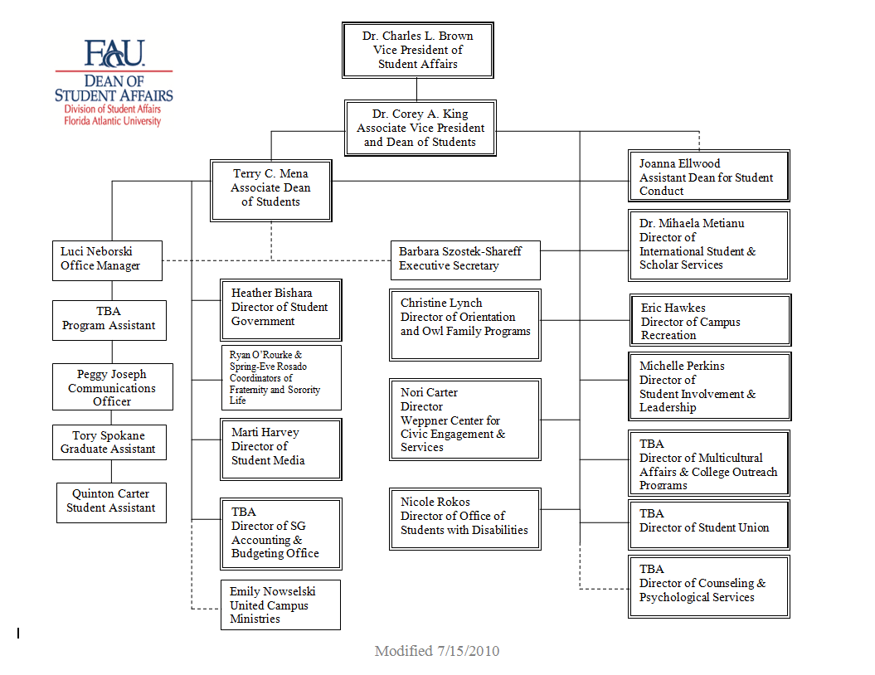

APPENDIX B

Student Conduct Statistics
2009-2010

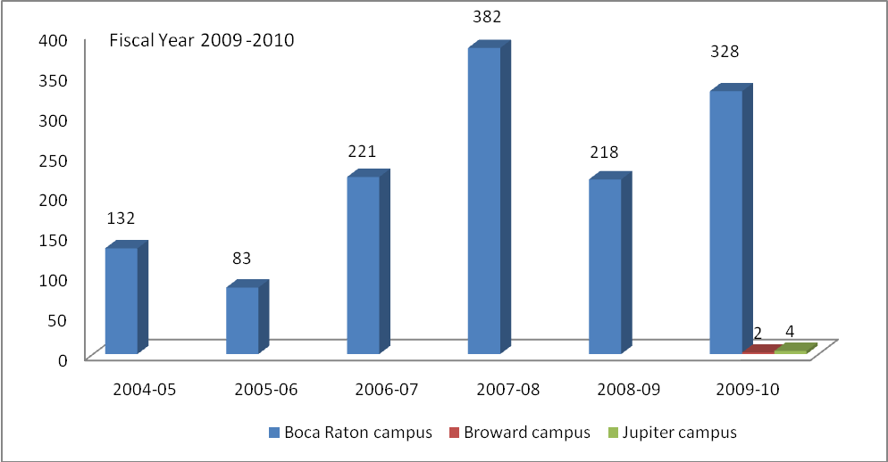
Involuntary Withdrawals
2009-2010

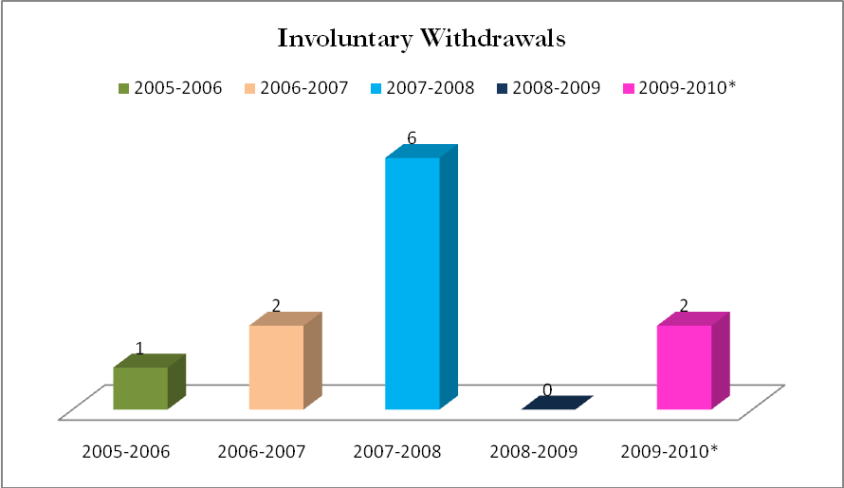
*Current Year

Housing and Residential Life
Student Conduct Statistics 2009-2010

Building | Incidents | Hearings Conducted | Recidivism | CS Hours | AOD Incidents | Hearings Conducted* | Recidivism | Students Removed
ALG | 3 | 4 | 0 | 40 | 3 | 3 | 0 | 1
GPT | 6 | 14 | 3 | 105 | 5 | 12 | 2 | 2
HPT | 18 | 51 | 3 | 110 | 12 | 41 | 5 | 4
IRT | 20 | 49 | 5 | 235 | 14 | 42 | 4 | 5
VIL | 8 | 57 | 0 | 130 | 5 | 50 | 0 | 2
TOTAL | 67 | 175 | 11 | 620 | 39 | 148 | 11 | 14
08-09 Totals | 162 | 336 | 36 | 2534 | 79 | 202 | 13 | 13

* Hearings conducted reports the total number of hearings conducted which includes students who had multiple hearings for different incidents. This is a higher number than what total number of students involved would be.

APPENDIX C

Total Withdrawals for Exceptional Circumstances
Academic Year 2009-2010

Total Withdrawals | 421
Approved | 361
Denied | 33
Petitions | 27
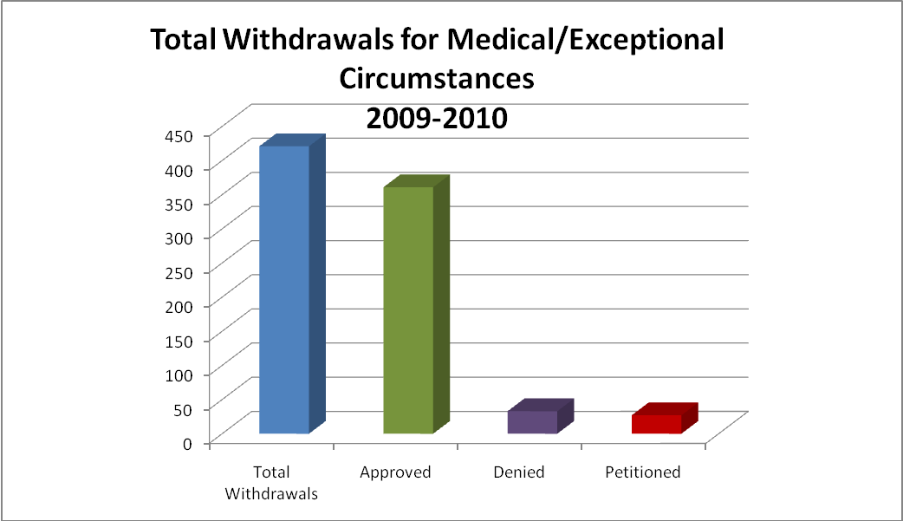

Total Withdrawals for Exceptional Circumstances
Academic Year 2009-2010 (Semesters)

 | Fall 2009 | Spring 2010 | Summer 2010
Approved | 162 | 142 | 55
Denied | 12 | 9 | 2
Petitions | 16 | 20 | 3
Total Withdrawals | 190 | 171 | 60

Appendix D

Student Contact Statistics
2009-2010

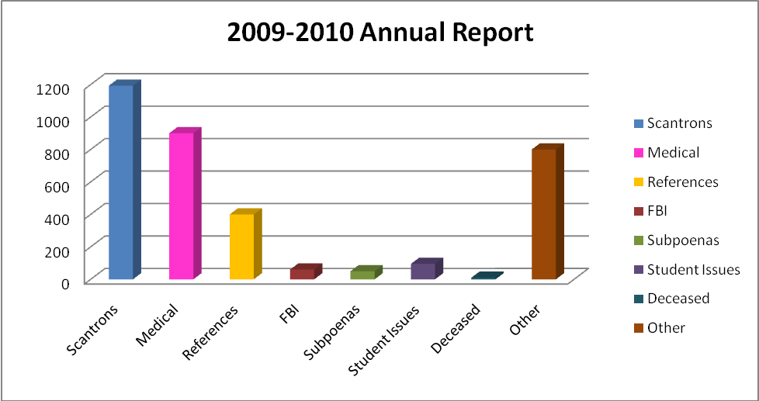

CATEGORY | NUMBERS
Scantrons | 1193
Medical | 900
Dean Clearance Letter (References, FBI, etc.)
References | 400
FBI | 60
Subpoenas | 50
Student Issues | 95
Deceased | 10
Other | 800
TOTAL | 3508

Appendix E

Alcohol and the Law Seminar

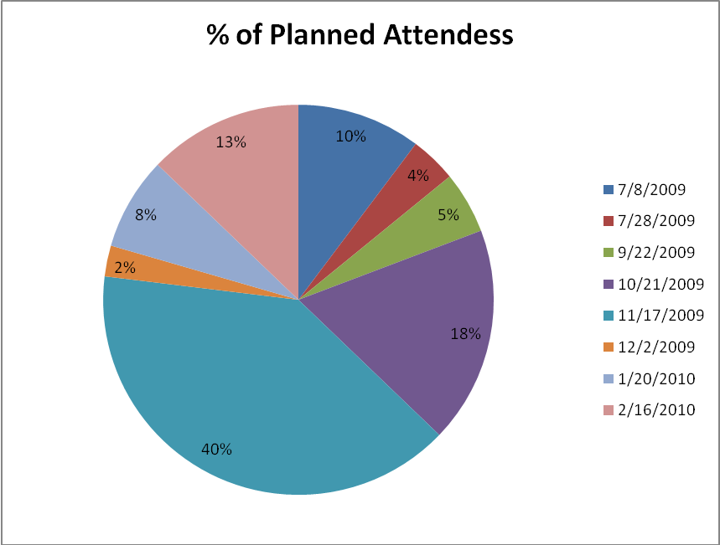

Seminar Dates | Planned Attendees | Actual Attendees | Surveys Completed | Male Actual Attendees | Female Actual Attendees
7/8/2009 | 8 | 3 | 3 | 1 | 2
7/28/2009 | 3 | 3 | 3 | 3 | 0
9/22/2009 | 4 | 4 | 0 | 1 | 3
10/21/2009 | 14 | 19 | 19 | 13 | 6
11/17/2009 | 31 | 29 | 25 | 15 | 14
12/2/2009 | 2 | 4 | 4 | 4 | 0
1/20/2010 | 6 | 3 | 3 | 2 | 1
2/16/2010 | 10 | 8 | 7 | 4 | 4
Totals | 78 | 73 | 64 | 43 | 30

